Well-Being Determinants: Ecosystem Analysis
Course: Research on Well-Being Science and Digital Social-Emotional Learning
Group Assignment
# | Name | Student ID / Role
1 | Addis Astatike | D11311809
2 | Debir Molalign | D11411811
3 | Tarus Kipkalis Dennis | M11411816
4 | Mathews Opiyo Opemba | M11411819
5 | Krittawit Krittayaruangroj (Chris) | Visiting Researcher

Step 1 — Brainstorm Determinants
Based on the five required categories, the following factors represent a holistic ecosystem of well-being. Each determinant was selected for its cross-domain impact and theoretical grounding.
Determinant | Category | Direction
Cognitive Resilience | Psychological | Positive
Social Support Networks | Social | Positive
Income Equality | Structural | Positive
Epigenetic Regulation | Biological | Neutral
Algorithmic Bias | Digital | Negative
Job Security | Structural | Positive
Neuroplasticity | Biological | Positive
Self-Efficacy | Psychological | Positive
Urban Green Spaces | Structural | Positive
Digital Connectivity | Digital | Neutral

Step 2 — Connect to Theory
Each determinant is mapped to a core psychological or well-being framework, explaining the mechanism through which it shapes individual and collective well-being.
Determinant | Theoretical Framework | Explanation
Income Equality | Diener's SWB | Financial stability provides the cognitive and material foundation for life satisfaction. Without it, higher-order well-being is structurally constrained.
Urban Green Spaces | Ryff's PWB | Access to nature directly supports Environmental Mastery — a core pillar of psychological well-being — by restoring attention and reducing stress.
Job Security | Self-Determination Theory | Stable employment creates the conditions for Competence (skill development) and Autonomy (self-directed work), two of the three basic psychological needs.
Social Support Networks | PERMA (Seligman) | Directly nourishes the Relationships (R) and Positive Emotions (P) pillars. Harvard's longitudinal research confirms social quality as the single strongest predictor of healthy ageing.
Self-Efficacy | Eudaimonic Well-Being | Belief in one's capacity for effective action drives self-realisation and purposeful functioning — the essence of eudaimonic well-being, distinct from hedonic pleasure.
Digital Connectivity | PERMA + SDT | Digital Connectivity operates as both an enabler and a risk factor for well-being. When equitably distributed and mindfully used, it extends access to healthcare, education, social connection and economic opportunity — satisfying core needs across PERMA and SDT. When poorly designed or unequally distributed, it reproduces structural inequality and introduces new psychological risks. The determinant is therefore not digital access itself, but the quality, equity and intentionality of that access.
Step 3 — Draw Your Ecosystem Map
The diagram below maps all 10 determinants as connected nodes around a central Well-Being hub.
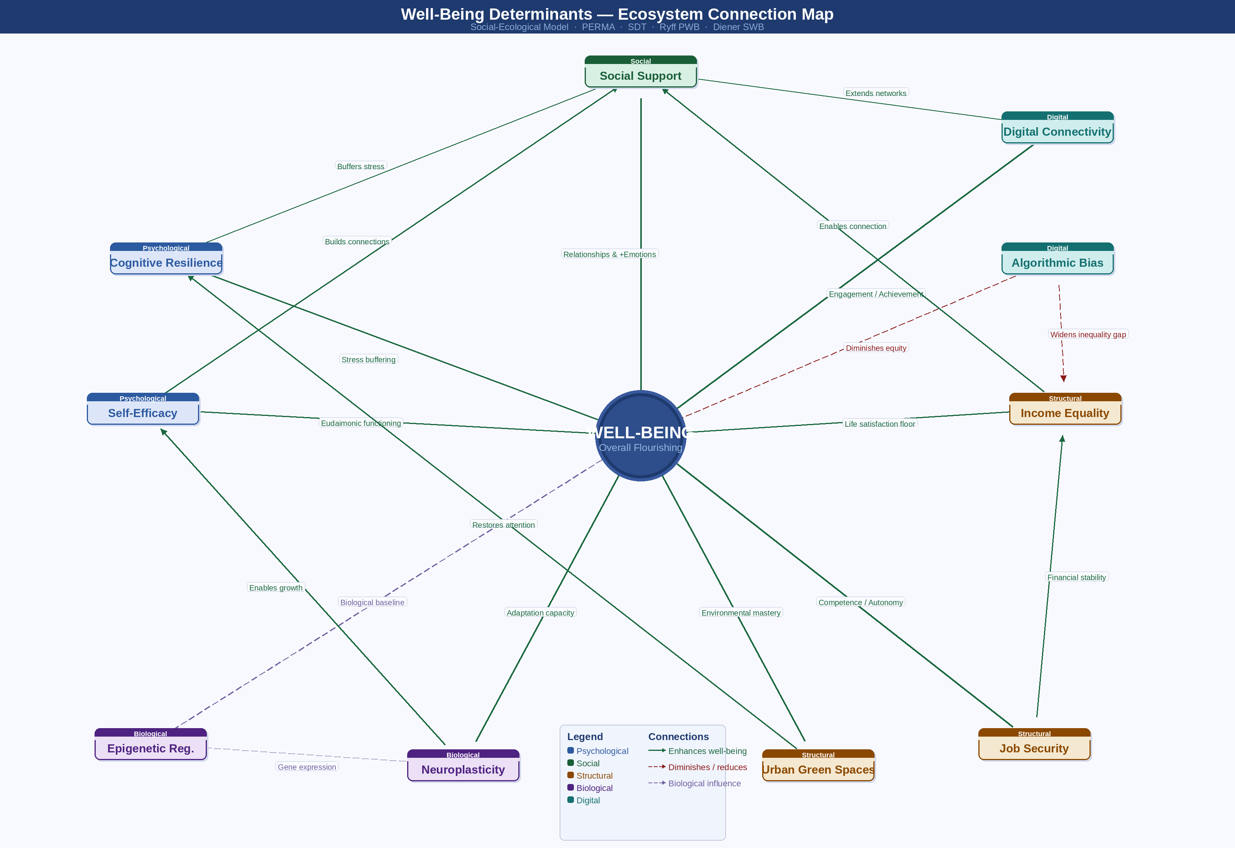
Green lines indicate positive (enhancing) connections; red dashed lines indicate negative or diminishing ones; grey dashed lines represent biological influences. Cross-connections between determinants show how each layer shapes the others.
Step 4 — Identify Insights
● Most Important Determinant
Social Support Networks. Consistent with findings from the Harvard Study of Adult Development, the quality of close relationships is one of the strongest predictors of long-term physical and psychological well-being.
● Most Surprising Insight
Digital Connectivity as a structural necessity. In 2026, the absence of digital access is no longer simply a "technology issue" — it is a structural barrier to healthcare, education, and social belonging, with direct consequences for well-being outcomes.
● Question to Explore Further
How do biological predispositions — such as temperament and neuroplasticity — interact with digital environments to produce divergent well-being outcomes in adolescents? This intersection of the biological core and the digital layer deserves dedicated longitudinal research.
Step 5 — Prepare for Class Sharing

1. Key Determinants: Structural factors such as Income Equality create the foundational environment in which Social Support can flourish. Without structural stability, even strong social networks are constrained in their protective effect.
2. Theory Connections: Both PERMA (Seligman) and Ryff's Psychological Well-Being model were applied to demonstrate that well-being is a multi-dimensional state of active functioning — not merely the absence of distress or the presence of pleasant feelings.
3. Most Interesting Insight: The emergence of Digital Determinants as a category that mirrors traditional structural factors. Our online ecosystem now shapes access, opportunity, and social belonging in ways that are structurally analogous to physical infrastructure.
References: PERMA · Seligman (2011) · Ryff's PWB · Ryff (1989) · SDT · Deci & Ryan (1985) · SWB · Diener (1984) · Harvard Study of Adult Development

